
CSA15 – CLOUD COMPUTING AND BIG DATA ANALYTICS

ASSIGNMENT 1 – CO1
Design, Analyse and Validate a Cloud-Based Solution for Migrating a Legacy University Management System
CO1: Apply cloud computing technologies including hardware–software evolution, virtualization, web services, and service models to develop cloud-based solutions.

Field | Details | Field | Details
Student Name | V Vaishnavi | Register Number | 192511056
Department / Section | CSA | Academic Year / Semester | 2025-2029
Faculty Name | Dr.R.Latha | Nature of Assignment | Individual
Duration | 1 Week | Total Marks | 50
Submission Date | 30.10.2026 | Evaluation Date

MARK SHEET (Rubric-based evaluation)
Task | Title | Max | Awarded | Evidence / evaluation focus
1 | Introduce Cloud Computing | 3 |  | Definition; characteristics; deployment models; scenario mapping
2 | Trace Evolution and Hardware Evolution | 3 |  | Timeline; hardware evolution; relevance to university
3 | Analyse Internet Software Evolution | 3 |  | Web/software evolution; SOA; APIs; scenario relevance
4 | Apply Server Virtualization | 5 |  | Hypervisor types; VM/container comparison; consolidation; limitations
5 | Apply Web Services | 4 |  | SOA and SOAP/REST; three university APIs; request/response examples
6 | Analyse IaaS, PaaS and SaaS | 5 |  | Responsibility layers; five-application mapping; comparison; providers
7 | Examine XaaS | 3 |  | Four or more variants; two justified choices; provider risks
8 | Design Cloud Solution Architecture | 5 |  | Labelled diagram; deployment/service models; scaling; security; DR
9 | Hands-on Implementation and Documentation | 4 |  | Running VM/container; PaaS/SaaS; tests; actual screenshots
10 | Evaluate and Recommend Final Solution | 7 |  | Three-way comparison; 3-year costs; risks; phased roadmap
11 | Day-4 Design Challenge | 8 |  | Impact; evaluation; adaptation; evidence-based defence
 | TOTAL | 50 |  | Percentage :

EVIDENCE VERIFICATION CHECKLIST

Tasks | Evidence expected | Status (✓ / P / ✗) | Evaluator note
1–3 | Conceptual explanations, comparisons and relevant illustrations | ✓ | Explanations and relevant scenario mapping documented
4 | Virtualization calculations with stated assumptions and peak-load caution | ✓ | Calculations present; practical capacity validation recommended
5–7 | API examples, service responsibility table and justified XaaS choices | ✓ | Required conceptual evidence documented
8 | Labelled architecture diagram, caption below figure and component justification | ✓ | Architecture documented; sizing assumptions need testing
9 | Actual code, environment details, execution logs, API outputs and screenshots | P | Procedures provided; actual execution evidence not established
10 | Cost assumptions, 3-year totals, risk controls and migration roadmap | ✓ | Estimates and rationale documented
11 | Day-4 changes, 10× load strategy, 99.9% target and 40-college isolation | ✓ | Design analysis documented; practical validation pending

IMPLEMENTATION EVIDENCE CHAIN

Evidence item | Status | Observation
Source code | ✓ | Flask REST API and Dockerfile provided in the proposed implementation
Virtualization | P | Docker container configuration documented; running-container evidence required
PaaS or SaaS | P | Managed web-service deployment procedure described; live deployment not verified
Functional test | P | Expected HTTP 200 response and JSON output documented; actual output required
Failure case | P | HTTP 404 test case documented; actual execution record required
Screenshots | P | Screenshot requirements identified; authentic screenshots need verification
Reproducibility | ✓ | Build commands, run commands, endpoints and expected results specified

OVERALL REMARKS

_______________  Student Signature | _______________  Faculty Signature | _______________  Program Director
MANDATORY SUBMISSION EVIDENCE CHECK
✓ = Present in documented answer; P = Partly present; ✗ = Missing / not satisfied
Task | Evidence expected | Status | Evaluator note
1 | Cloud definition, characteristics, deployment models and scenario mapping | ✓ | All conceptual requirements covered
2 | Evolution timeline, hardware development and university relevance | ✓ | Well explained with relevant examples
3 | Internet software evolution, SOA and APIs | ✓ | Clear explanation and scenario relevance
4 | Hypervisors, VM/container comparison and consolidation calculations | ✓ | Calculations included; peak-load limitations discussed
5 | SOAP/REST comparison and three university APIs | ✓ | API methods and request/response examples documented
6 | IaaS/PaaS/SaaS responsibility layers and application mapping | ✓ | All five applications categorized with justification
7 | XaaS variants and two justified selections | ✓ | Six variants explained; DBaaS and DRaaS recommended
8 | Labelled architecture, scaling, security and disaster recovery | ✓ | Design and component justifications documented
9 | Working container, PaaS/SaaS deployment, actual tests and screenshots | P | Code and procedures provided; actual execution evidence requires verification
10 | Three-year cost comparison, risks and migration roadmap | ✓ | Cost assumptions, calculations and recommendations included
11 | Impact analysis, 10× load, 99.9% availability and tenant isolation | ✓ | Changed requirements evaluated; load-test evidence recommended

IMPLEMENTATION EVIDENCE CHAIN
Evidence item | Status | Observation
Source code | ✓ | Python Flask REST API and Dockerfile documented
Virtualization | P | Docker build and run procedures provided; execution screenshot required
PaaS or SaaS | P | Cloud deployment steps described; actual deployment confirmation required
Functional test | P | HTTP 200 and expected JSON response documented; actual test output required
Failure case | P | HTTP 404 test case included; execution evidence required
Screenshots | P | Required screenshots identified but authenticity and completeness not verified
Reproducibility | ✓ | Installation, configuration, commands and testing steps documented
Interpretation | ✓ | Technical outcomes and implementation limitations explained
Code and report consistency | ✓ | Proposed API, Docker configuration and testing procedure are aligned

SUBMISSION CHECKLIST (Not Separately Marked)
Requirement | Status
All 11 tasks answered | ☒ Yes ☐ Partly ☐ No
Cloud concepts and comparisons explained | ☒ Yes ☐ Partly ☐ No
Virtualization calculations included | ☒ Yes ☐ Partly ☐ No
API examples and service models explained | ☒ Yes ☐ Partly ☐ No
Cloud architecture diagram included | ☒ Yes ☐ Partly ☐ No
Implementation and testing evidence provided | ☐ Yes ☒ Partly ☐ No
Three-year cost analysis and roadmap included | ☒ Yes ☐ Partly ☐ No
Day-4 design challenge completed | ☒ Yes ☐ Partly ☐ No
Figures and screenshots included | ☐ Yes ☒ Partly ☐ No
Table and figure numbering correct | ☐ Yes ☒ Partly ☐ No
Viva recommended | ☒ Yes ☐ No

CSA15 – Cloud Computing and Big Data Analytics
ASSIGNMENT 1
CO1: Apply cloud computing technologies including hardware–software evolution, virtualization, web services, and service models to develop cloud-based solutions.

Assignment Title: Design, Analyse and Validate a Cloud-Based Solution for Migrating a Legacy University Management System (Total Marks – 50)
Duration: 1 week
Scenario – Smart Campus Cloud Migration
A multi-campus university currently runs its Student Information System, Learning Management System, Library System, Exam Portal and Email on ageing physical servers in a single on-premise data centre. Each application has its own dedicated server, which stays idle for most of the year but fails to cope during admissions, result publication and online-exam weeks.
The university's current environment is:
- 12 physical servers, average CPU utilisation of about 15%, with peaks above 95% during admissions and exams
- Approximately 25,000 students and 2,000 staff across 4 campuses
- Applications built as large monolithic programs, with no public interfaces for mobile apps or partner colleges
- High capital expenditure, slow procurement (6–8 weeks per server) and no disaster recovery site
As a cloud consultant, you must study how computing evolved to the cloud model, and then design a cloud-based solution that uses virtualization, web services and an appropriate mix of service models (IaaS, PaaS, SaaS and XaaS) for the university. All recommendations must be justified in terms of cost, scalability, availability and manageability.
Design Challenge:
On Day 4, the university announces that it will launch a mobile app and open student-record and fee-payment services to 40 affiliated colleges. Expected load is 10 times the current peak, with a requirement of 99.9% availability and a limited operating budget. Re-evaluate your original design and decide whether it should be retained, modified or redesigned.
TASK 1 – Introduce Cloud Computing and Map It to the Scenario (3 Marks)
Design and Propose cloud computing model for the context of the university's problems.
- Definition of cloud computing and the five essential characteristics (on-demand self-service, broad network access, resource pooling, rapid elasticity, measured service)
- Deployment models (public, private, hybrid, community) and which one suits the university
- Three problems of the current on-premise setup and how each cloud characteristic addresses them
- Benefits and limitations of cloud adoption for the university
Evidence Expected
A clear explanation of cloud characteristics and deployment models, mapped to the university's actual problems.
TASK 2 – Trace the Evolution and Hardware Evolution (3 Marks)
Trace how computing infrastructure evolved to make cloud computing possible.
- A timeline from mainframes, minicomputers and PCs, to client–server, clusters, grid computing, utility computing and cloud
- Hardware evolution: multi-core processors, commodity servers, high-capacity storage, high-speed networking and data centres
- How each stage solved a limitation of the previous one
- Which stage the university's current system corresponds to, with reasons
Evidence Expected
A labelled timeline or diagram, with a justified explanation of how hardware advances enabled the cloud.
TASK 3 – Analyse Internet Software Evolution (3 Marks)
Explain how internet software evolved and why it supports cloud services.
- Evolution from static web pages to dynamic web, Web 2.0, SOA, mashups and cloud-hosted applications
- Role of browsers, HTTP, AJAX and APIs in delivering software over the internet
- Comparison between desktop software, client–server software and web-delivered software
- How this evolution affects the design of the university's applications
Evidence Expected
A comparative explanation of software evolution stages, linked to the university's application design.
TASK 4 – Apply Server Virtualization (5 Marks)
Apply server virtualization to consolidate the university's 12 physical servers.
- Explain how a hypervisor works, and distinguish Type-1 and Type-2 hypervisors, with examples
- Compare full virtualization, para-virtualization, OS-level virtualization (containers) and hardware-assisted virtualization
- Propose which applications should run as virtual machines and which as containers, with reasons
- Calculate the consolidation: with an average utilisation of 15% per server and a target host utilisation of 70%, estimate how many physical hosts are needed (show your assumptions and working)
- Discuss live migration, snapshots and resource over-commitment as benefits, and the risks of virtualization (noisy neighbour, hypervisor failure, security isolation)
Show your calculation. A final number without working will not receive full credit.
Evidence Expected
A justified virtualization plan with a worked consolidation calculation and discussion of benefits and risks.
TASK 5 – Apply Web Services (4 Marks)
Analyse web services to expose the university's functions to other systems.
- Overview of web services and their role in cloud and SOA
- Compare SOAP, WSDL, UDDI and RESTful services (HTTP methods, JSON/XML)
- Identify at least three university functions to expose as web services (for example, result lookup, fee payment, library search) and define the endpoint, method and sample request/response for each
- Justify whether SOAP or REST is more suitable for each function
Evidence Expected
A defined set of web services with sample request/response formats and a justified choice of SOAP or REST
TASK 6 – Analyse the Service Models: IaaS, PaaS and SaaS (5 Marks)
Analyse which service model fits each university application.
- Define IaaS, PaaS and SaaS, and show who manages which layer (hardware to application) in each model
- Categorise the five university applications (SIS, LMS, Library, Exam Portal, Email) into IaaS, PaaS or SaaS, with reasons
- Compare the models on control, cost, scalability, maintenance effort and vendor lock-in
- Give one real provider example for each model
Present your categorisation in a table, but explain the reasoning behind each decision. A table alone is not sufficient.
Evidence Expected
A reasoned mapping of applications to service models, supported by a layer-wise responsibility comparison.
TASK 7 – Examine XaaS (3 Marks)
Examine the broader XaaS (Anything-as-a-Service) concept for the university.
- Explain XaaS and describe at least four variants (for example DaaS, BaaS/MBaaS, FaaS, DBaaS, Security-as-a-Service, Disaster-Recovery-as-a-Service)
- Select two XaaS offerings that would benefit the university, and justify them
- Discuss the risks of over-reliance on multiple 'as-a-Service' providers
Evidence Expected
An analysis of XaaS variants, with justified selection of two offerings for the university.
TASK 8 – Design the Cloud Solution Architecture (5 Marks)
Bloom's Level: Level 6 – Create | Action verbs: Design, Construct, Propose
Create a complete cloud architecture for the university by combining virtualization, web services and service models.
- An architecture diagram showing users, load balancer, web/application tier, database tier, storage, API layer and DR region
- The deployment model and the service model chosen for each component
- How elasticity (auto-scaling) will handle admissions and exam peaks
- Basic security and availability measures (access control, encryption, backup, multi-zone deployment)
Evidence Expected
A labelled architecture diagram with written justification for each component and design decision.
TASK 9 – Hands-on Implementation and Documentation (4 Marks)
Implement a small proof-of-concept of your design using a free-tier cloud account or a local virtualization tool.
- Create a virtual machine or container (using AWS/Azure/GCP free tier, VirtualBox, or Docker) and host a simple web page or REST API for one university function
- Deploy a SaaS or PaaS component (for example a cloud-hosted database, a serverless function or a static site)
- Test the web service with a client (browser, Postman or curl) and record the output
- Provide screenshots, configuration steps and any issues faced
Evidence Expected
Annotated screenshots and clear, reproducible steps showing that the proof-of-concept works.
TASK 10 – Evaluate and Recommend the Final Solution (7 Marks)
Evaluate your design and recommend the final cloud solution for the university.
- Compare on-premise, IaaS-based and PaaS/SaaS-based options on cost (CapEx vs OpEx), scalability, availability, security and effort
- Estimate a simple 3-year cost comparison using stated assumptions
- Identify the main risks (vendor lock-in, data privacy, downtime, skills gap) and give mitigation steps
- Provide your final recommendation and a short migration roadmap (which application moves first, and why)
Your recommendation must be supported by the analysis in the previous tasks. Choosing a popular cloud provider without justification is not sufficient.
Evidence Expected
A technically justified recommendation, supported by a cost comparison, risk analysis and migration roadmap.
DAY-4 DESIGN CHALLENGE
TASK 11 – Re-evaluate and Adapt the Design (8 Marks)
Changed Requirement
The university will now launch a mobile app and open student-record and fee-payment services to 40 affiliated colleges. Expected load is 10 times the current peak, availability must be 99.9%, and the operating budget is limited.
Re-evaluate your original design in response to these changed conditions. You may:
RETAIN → MODIFY → or REDESIGN
your original solution.
Impact Analysis – 2 Marks
Discuss:
- What has changed from the original problem
- Which original assumptions (load, users, availability, cost) are affected
- Why the web services and APIs now become critical
- How multi-tenant access by 40 colleges affects security and isolation
Evidence Expected: A clear analysis of how the changed requirements affect the original cloud design.
Evaluation of the Original Design – 2 Marks
Discuss:
- Whether the chosen service models and virtualization plan can handle a 10x load
- Whether auto-scaling and the single-region deployment are sufficient for 99.9% availability (about 8.76 hours of downtime allowed per year)
- Whether cost remains acceptable under the new load
- Whether another service model or XaaS offering would give better overall results
Evidence Expected: A technically supported evaluation of the original design under the new conditions.
Adaptation or Redesign – 2 Marks
Discuss:
- Decide whether to retain, modify or redesign the solution
- Describe the revised architecture (for example API gateway, container orchestration, serverless components, multi-zone deployment or a hybrid model)
- Explain what changed in the service model mix and in the virtualization approach
- If you retain the original design, give sufficient technical justification for why no change is required
Evidence Expected: An appropriate design response to the changed requirement, with clear technical reasoning.
Evidence-Based Defence – 2 Marks
Discuss:
- Capacity and availability calculations
- Cost comparison between the original and the revised design
- Security and multi-tenancy considerations
- Trade-offs such as vendor lock-in, complexity and migration effort
Evidence Expected: A well-supported final decision that follows logically from the analysis.
MARK DISTRIBUTION
Task | Title | Bloom's Level | Marks
Task 1 | Cloud Computing – Introduction & Characteristics | L2 – Understand | 3
Task 2 | Evolution & Hardware Evolution | L2 – Understand | 3
Task 3 | Internet Software Evolution | L2 – Understand | 3
Task 4 | Server Virtualization | L3 – Apply | 5
Task 5 | Web Services | L3 – Apply | 4
Task 6 | Service Models: IaaS, PaaS, SaaS | L4 – Analyze | 5
Task 7 | XaaS | L4 – Analyze | 3
Task 8 | Design the Cloud Solution Architecture | L6 – Create | 5
Task 9 | Hands-on Implementation & Documentation | L3 – Apply | 4
Task 10 | Evaluate & Recommend the Final Solution | L5 – Evaluate | 7
 | Subtotal

Task 11 | Day-4 Design Challenge | L4 / L5 / L6 | 8
 | TOTAL |  | 50

TASK 1: Introduce Cloud Computing and Map It to the Scenario

Core Insight: Imagine every household running its own diesel generator sized for the hottest summer afternoon. Most of the year the generators idle, and on the hottest day they still fail. That is the university's data centre today. Cloud computing is the move from owning generators to plugging into the grid and paying for the units consumed.

1.1 Definition of Cloud Computing
Cloud computing is a model, formalised by NIST in Special Publication 800-145, for obtaining convenient, on-demand network access to a shared pool of configurable computing resources such as servers, storage, networks, applications and services. These resources can be provisioned and released rapidly with minimal management effort or provider interaction. In simple words, computing is consumed as a service rather than owned as a product.

1.2 The Five Essential Characteristics, Mapped to the University
Characteristic | Meaning | University scenario
On-demand self-service | Users provision resources themselves, without human help from the provider. | An administrator launches a server in minutes instead of waiting 6 to 8 weeks for procurement.
Broad network access | Services are reachable over the network from standard devices. | Four campuses, the planned mobile app and 40 affiliated colleges reach the same services over the internet.
Resource pooling | The provider serves many tenants from a shared pool, assigned dynamically. | The university draws from a large shared pool instead of 12 dedicated servers that sit idle.
Rapid elasticity | Capacity scales out and in quickly, often automatically. | Extra capacity appears for admissions, results and exam weeks and disappears afterwards.
Measured service | Usage is metered and billed, and can be reported per consumer. | The university pays for exam week when it is used, and can charge costs back to each department.

1.3 Deployment Models and the Best Fit
Model | Description | Fit for the university
Public cloud | Owned by a provider and shared by many customers. | Excellent for elastic peaks and for disaster recovery, but sensitive records raise privacy and sovereignty concerns.
Private cloud | Operated for one organisation, on-site or hosted. | Good control for student records, but small capacity cannot absorb a ten-fold peak economically.
Community cloud | Shared by organisations with common concerns. | A natural future fit for the 40 affiliated colleges sharing records and fee services.
Hybrid cloud | Two or more models linked by standard technology so workloads can move or burst. | Best fit: private core for sensitive data, public cloud for peaks and recovery.

Why hybrid wins. The university's demand is spiky and its data is sensitive. A pure private cloud would recreate the idle-capacity problem, and a pure public cloud would place all student records outside its direct control and may conflict with the Digital Personal Data Protection Act 2023. Hybrid keeps the crown-jewel data close and rents elasticity only when needed.

1.4 Three Problems and the Cloud Characteristics That Solve Them
A useful measure is the peak-to-average ratio. Here it is about 95% / 15%, or roughly 6.3. To survive its peaks, the university must own about six times the capacity its average work needs, which explains both the waste and the failures.
Problem | Evidence | Cloud characteristics that address it
1. Idle capacity yet failure at peak | 15% average utilisation, over 95% at peaks. | Rapid elasticity adds capacity only during peaks; measured service means no payment for the idle year.
2. High capital cost and slow procurement | Large capex; 6 to 8 weeks per server. | On-demand self-service removes the wait; resource pooling converts capex into pay-as-you-go operating expense.
3. No disaster recovery and a single site | One data centre; a fire, flood or power loss stops everything. | Broad network access with resource pooling lets workloads and backups live in other regions, restoring service quickly.

1.5 Benefits and Limitations in the Four Dimensions
Dimension | Benefit | Limitation and mitigation
Cost | Capex becomes opex; no idle hardware. | Uncontrolled usage can inflate bills; use budgets, alerts and reserved capacity for the steady baseline.
Scalability | Peaks handled automatically. | Applications must be designed to scale out; the monoliths need re-architecting.
Availability | Multi-zone redundancy and cloud disaster recovery. | Dependence on internet links and the provider; use redundant links and an exit plan.
Manageability | Less hardware to patch and replace. | New skills and shared-responsibility rules; train staff and use managed services.
Security and compliance | Provider-grade physical security. | Data sovereignty and vendor lock-in; encrypt data, keep records in-region and use open standards.

1.6 Proposed Service-Model Mix (IaaS, PaaS, SaaS, XaaS)
Component | Model | Justification
Email | SaaS | Commodity function; no servers to run; high availability and low management effort.
Learning Management System | PaaS (containers) | Stateless web tier scales automatically for exam weeks; the platform handles patching.
Student Information System core | IaaS (VMs) and managed database | Legacy monolith moves with minimum change now and is modernised gradually.
Exam Portal | PaaS with autoscaling | Sharp, short peaks suit pay-per-use elasticity.
Library System | SaaS or small container | Low load; cheapest to host or subscribe.
Disaster recovery, identity, payments | XaaS (DRaaS, IDaaS, payment gateway) | Specialist services bought as needed give availability and security without building them.

TASK 2: Trace the Evolution and Hardware Evolution
Core Insight: Each computing era is a patch for the previous era's biggest complaint. Read the history as a chain of limitations, and cloud computing appears as the first model that patches nearly all of them at once.

2.1 Labelled Timeline
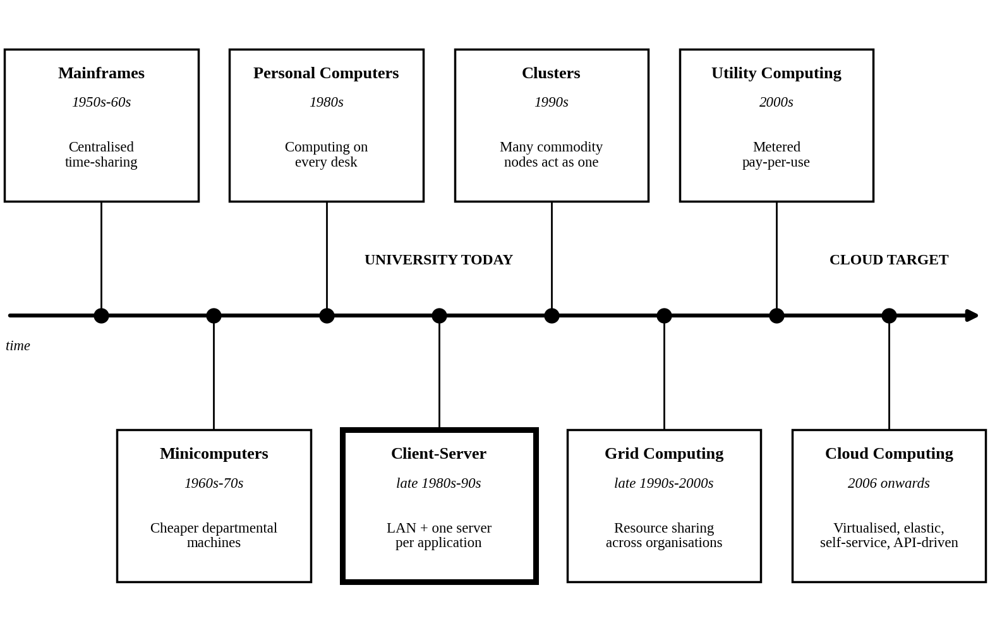
Figure 1: Evolution of computing infrastructure. The bold box marks the stage the university's system corresponds to today, and the label on the right marks the target.

2.2 How Each Stage Solved a Limitation of the Previous One
Stage | Key idea | Limitation it solved | New limitation
Mainframes (1950s-60s) | Central machine shared by many users (for example IBM System/360, 1964). | Computers were one-user, one-job machines. | Very costly, centralised, dumb terminals.
Minicomputers (1960s-70s) | Affordable departmental machines (for example DEC PDP-11, 1970). | Mainframe cost and queueing. | Isolated, incompatible systems.
Personal computers (1980s) | Computing on every desk (IBM PC, 1981). | Dependence on a central or departmental machine. | Data scattered; hard to share and manage.
Client-server (late 1980s-90s) | Networked clients using shared database and application servers. | Data islands on PCs. | One server per application, vertical scaling, heavy administration.
Clusters (1990s) | Commodity machines joined to behave as one (Beowulf, 1994). | Single servers could not scale or survive failure. | Confined to one site and one owner.
Grid computing (late 1990s-2000s) | Resources shared across organisations (for example SETI@home, 1999). | Cluster limits on size and ownership. | Complex middleware, mainly scientific, no simple billing.
Utility computing (2000s) | Metered, pay-per-use computing like electricity. | Lack of a business model for sharing. | Immature virtualisation and self-service.
Cloud computing (2006 onwards) | Virtualised, elastic, self-service, API-driven services (Amazon S3 and EC2, 2006). | Provisioning delay, idle capacity and rigid billing. | Lock-in, connectivity and governance concerns.

2.3 Hardware Evolution That Made the Cloud Possible
Hardware advance | What changed | Contribution to cloud
Multi-core processors (mid-2000s) | Several cores per chip instead of faster single cores. | Many VMs run in parallel on one host.
Hardware virtualization support (Intel VT-x 2005, AMD-V 2006) | Processor features that trap and isolate guest code. | Efficient, secure virtual machines.
Commodity servers | Inexpensive standard x86 machines replaced costly proprietary ones. | Low-cost pools that tolerate failure through software.
High-capacity storage (disk growth, SSD, NVMe) | Far more capacity and speed per rack. | Large shared, low-latency storage pools.
High-speed networking (10, 40, 100 Gigabit Ethernet and fibre) | Fast, low-latency links. | Remote delivery and distributed storage and compute.
Data centres (hyperscale, standard modules) | Standardised, automated and energy-efficient facilities. | Economies of scale passed on as pay-per-use pricing.

2.4 Where Is the University Today?
The current system corresponds to the client-server stage, specifically its late, pre-virtualisation form. The reasons are:
- One dedicated server per application, the defining pattern of client-server.
- Single-site, owner-managed hardware with no pooling, no clustering and no recovery site.
- Capacity bought for the peak and manual procurement, so there is no elasticity or metering.
- Monolithic applications without public interfaces, meaning no service orientation.
The university has effectively skipped four stages: clusters, grid, utility and cloud. The migration is therefore a leap of about four stages, and virtualisation is the bridge that makes the leap manageable.

TASK 3: Analyse Internet Software Evolution
Core Insight: Software has travelled from something you carry home on a disk, to something you visit, to something that visits you through a phone. Each step moved the application closer to the network and further from the user's machine, and the cloud is the destination of that journey.
3.1 Evolution of Internet Software
Stage | Characteristic | Cloud relevance
Static web (1990s) | Fixed HTML pages served over HTTP. | Established the browser and HTTP as a universal delivery channel.
Dynamic web (late 1990s) | Pages generated by server code and databases (CGI, PHP, ASP, JSP). | Introduced real applications such as portals and online shops.
Web 2.0 (mid-2000s) | Interactive, user-driven sites using AJAX. | Browser applications began to rival desktop software.
Service-Oriented Architecture (2000s) | Reusable services with published contracts (SOAP, WSDL). | Business functions became network services.
Mashups | New applications built by combining existing web APIs. | Showed that composing services is faster than building from scratch.
Cloud-hosted applications | Applications delivered as SaaS and built from REST APIs, often as microservices. | Delivery, scaling and billing are all provided as services.

3.2 Role of Browsers, HTTP, AJAX and APIs
- Browser: a universal client that runs on any device, so nothing needs to be installed and every user always runs the current version.
- HTTP: a simple, stateless request-response protocol that passes through firewalls and defines uniform methods such as GET and POST, which makes services easy to scale behind load balancers.
- AJAX: asynchronous requests (through XMLHttpRequest) update part of a page without reloading it, giving web applications desktop-like responsiveness.
- APIs: machine-readable contracts that let one program use another's functions, which is how mobile apps, partner colleges and cloud services connect.

3.3 Desktop versus Client-Server versus Web-Delivered Software
Aspect | Desktop software | Client-server | Web-delivered (cloud)
Installation | On every machine. | Client on every machine, server in the data centre. | None; open a browser or app.
Updates | Manual, per machine. | Client and server both need updates. | Central, instant.
Platform dependence | High. | Often high. | Low; any device with a browser.
Scalability | Not applicable. | Vertical, limited by the server. | Horizontal, elastic.
Data location | Local. | Central server. | Provider's cloud, available anywhere.
Cost model | Licence per copy. | Licence plus servers. | Subscription or pay-per-use.

3.4 Effect on the Design of the University's Applications
The monoliths cannot serve a mobile app or partner colleges because they have no public interfaces and cannot scale piece by piece. The recommended path is the Strangler Fig pattern, named by Martin Fowler: new services are built around the old monolith and gradually take over its functions, until the old core can be retired. This avoids a risky big-bang rewrite.
Application | Design change | Reason
Student Information System | Expose records and fee functions through REST APIs; separate the database tier; gradually split into services. | Needed by the mobile app and affiliated colleges.
Learning Management System | Stateless web tier in containers; sessions held in a shared cache; content on object storage and a content delivery network. | Scales for exam weeks.
Exam Portal | Queue-based submission and autoscaling front end. | Absorbs sudden bursts without losing answers.
Library System | Search API and a responsive web interface. | Light, read-heavy and easily reused.
Email | Move to a SaaS suite. | Not a competitive function; offloads availability and security.

TASK 4: Apply Server Virtualization (5 Marks)
Core Insight: Twelve servers working at 15% is like twelve buses each carrying two passengers. Virtualization puts the passengers on three full buses, keeps one spare bus in the garage, and still lets any passenger switch buses without stopping.

4.1 How a Hypervisor Works
A hypervisor is a thin layer of software that creates and manages virtual machines. It divides the physical CPU, memory, storage and network into virtual resources. It schedules each virtual CPU on a physical core, maps each VM's memory to real memory through nested page tables, emulates or passes through devices, and traps privileged instructions so that no guest can interfere with another guest or with the host. To each guest operating system the VM looks like a complete private computer.
Type | Position | Examples | Typical use
Type-1 (bare-metal) | Runs directly on hardware. | VMware ESXi, Microsoft Hyper-V, Xen, KVM. | Production datacenter, including this project.
Type-2 (hosted) | Runs as an application on a host OS. | VMware Workstation, Oracle VirtualBox. | Development, testing and teaching.

4.2 Comparison of Virtualization Techniques
Technique | How it works | Guest change | Performance and isolation
Full virtualization | Complete hardware emulation or binary translation; guest runs unaware. | None. | Good isolation; some overhead without hardware help.
Para-virtualization | Guest uses hypercalls to talk to the hypervisor (for example Xen PV). | Guest kernel modified. | Lower overhead; fewer supported guests.
OS-level (containers) | Containers share the host kernel and are isolated by namespaces and control groups (Docker, LXC). | None, but same kernel. | Near-native speed, fast start, weaker isolation than VMs.
Hardware-assisted | CPU extensions (Intel VT-x, AMD-V, nested page tables) handle trapping and memory mapping. | None. | Near-native speed with strong isolation; the basis of modern hypervisors.

These are not rivals: modern platforms run full virtualization on top of hardware assistance, and then run containers inside the VMs.

4.3 Which Applications Run as VMs and Which as Containers
Application | Choice | Reason
Student Information System database and legacy monolith | VM | Legacy software, strong isolation, and the sensitive-records requirement.
SIS API layer (new) | Containers | Stateless services that need to scale and release quickly.
Learning Management System web tier | Containers | Stateless; scales out for exam weeks. Its database stays in a VM.
Exam Portal front end | Containers | Short, sharp bursts need fast start-up; answers go to a queue and a VM database.
Library System | Container (or SaaS) | Light workload; cheap and portable.
Email | Not virtualised on-site; SaaS | No benefit in running it locally.

4.4 Consolidation Calculation
Assumptions:
- Each of the 12 servers has capacity of 1 server-unit, and the new hosts have the same capacity as an old server (a conservative assumption, since newer hardware is faster).
- Average utilisation per server is 15%, and the target host utilisation is 70%, which leaves 30% headroom for fluctuations.
- Virtualization overhead is taken as 10% (hypervisor and virtual device cost).
- CPU is the limiting resource; memory and storage are assumed to be sized in proportion and must be verified during planning.
Formula: Hosts = (sum of average load x (1 + overhead)) / (host capacity x target utilisation), rounded up.
Step 1 (average demand): 12 x 0.15 = 1.8 server-units.
Step 2 (add overhead): 1.8 x 1.10 = 1.98 server-units.
Step 3 (divide by usable capacity per host): 1.98 / 0.70 = 2.83, which rounds up to 3 hosts. Without overhead the result is 1.8 / 0.70 = 2.57, which also rounds up to 3.
Step 4 (high availability): add one spare host so that the cluster survives a host failure (N+1): 3 + 1 = 4 hosts.
Result: 12 physical servers are replaced by 3 working hosts (a 4:1 consolidation ratio) and 1 spare. The host count falls by 75% before the spare and by 66.7% with it (12 to 4).
Peak sensitivity. Sizing for the average is not the same as sizing for the peak, so the same method was repeated for peak scenarios (the assumption that four servers peak at 95% simultaneously is mine):
Scenario | Demand (server-units) | With 10% overhead | Hosts at 70%
Average load | 12 x 0.15 = 1.80 | 1.98 | 2.83, so 3 (4 with spare)
Busy period: 4 servers at 95%, 8 at 15% | 4 x 0.95 + 8 x 0.15 = 5.00 | 5.50 | 7.86, so 8
Worst case: all 12 at 95% | 12 x 0.95 = 11.40 | 12.54 | 17.91, so 18

Interpretation: a local cluster sized for the worst case would need 18 hosts, more than the 12 servers the university owns today. The sensible design is therefore a small, efficient private core of about 4 hosts for the steady load, with the peaks handled by cloud bursting. This single calculation justifies the hybrid decision made in Task 1.
Over-commitment illustration. If each old server had 8 cores, the 12 VMs would hold 96 virtual CPUs. On 3 hosts with 24 physical cores, that is a vCPU-to-core ratio of 4:1 (3:1 on 4 hosts), which is safe only because the average utilisation is low.

4.5 Benefits and Risks of Virtualization
Item | Benefit or risk | Handling
Live migration | A running VM moves between hosts without noticeable downtime, so hosts can be patched or repaired without stopping services. | Needs shared storage and a fast network.
Snapshots | A point-in-time state allows quick rollback before upgrades. | Use short-lived snapshots; long chains slow down storage.
Over-commitment | More virtual resources than physical ones raises utilisation and cuts cost. | Monitor CPU ready time and memory ballooning.
Noisy neighbour (risk) | One VM starves others of CPU, memory or I/O. | Resource pools, shares, limits, reservations and storage QoS.
Hypervisor failure (risk) | One host failure stops every VM on it. | HA cluster with a spare host, automatic restart, regular backups and prompt patching.
Security isolation (risk) | VM escape or side-channel attacks could cross VM boundaries. | Patching, network segmentation and dedicated hosts for exam and student-record systems.

TASK 5: Apply Web Services (4 Marks)
Core Insight: A web service is a restaurant's service window. The kitchen (university system) stays private and complex, while the window accepts clearly formatted orders and returns standard dishes. The mobile app and each affiliated college become customers who never need to enter the kitchen.

5.1 Overview of Web Services in Cloud and SOA
A web service is a software function made available over a network through standard protocols so that different systems, written in different languages and running on different platforms, can use it. In a Service-Oriented Architecture, systems are built from loosely coupled, reusable services described by contracts. Cloud platforms are themselves delivered through web services, so exposing the university's functions as services is what allows its applications to serve the mobile app and the 40 colleges.

5.2 SOAP, WSDL, UDDI and REST Compared
Technology | What it is | Format and key features | Strength and weakness
SOAP | A messaging protocol. | XML envelope with header and body; WS-Security and transaction extensions; usually over HTTP. | Formal, secure and standardised; verbose and heavy.
WSDL | An XML language describing a service's operations, messages and endpoints. | Machine-readable contract from which client code is generated. | Precise contracts; complex to write.
UDDI | A registry for publishing and discovering services. | Services are listed and found by category. | Elegant in theory; rarely used on the public internet today.
REST | An architectural style, not a protocol. | Resources identified by URLs; HTTP methods GET (read), POST (create), PUT (replace or update) and DELETE; JSON or XML; stateless and cacheable. | Simple, light, fast and mobile-friendly; contracts and security conventions are looser.

The service triangle: a provider publishes its WSDL to a registry (UDDI); a requester finds it, then binds to the service and calls it using SOAP. REST skips the registry and the formal contract, and instead relies on well-documented URLs and standard HTTP.

5.3 University Functions Exposed as Web Services
Service 1: Result Lookup (REST). Endpoint: GET https://api.university.edu/v1/students/{studentId}/results?semester=2026-ODD. Authentication: OAuth 2.0 bearer token over HTTPS.
Request:
GET /v1/students/CS2026-0412/results?semester=2026-ODD
Authorization: Bearer (access token)
Accept: application/json

Response (200 OK):
{ "studentId": "CS2026-0412",
"semester": "2026-ODD",
"results": [
{"course": "CC301", "grade": "A", "credits": 4},
{"course": "DB302", "grade": "B+", "credits": 3} ],
"sgpa": 8.7 }

Service 2: Fee Payment (REST). Endpoint: POST https://api.university.edu/v1/students/{studentId}/payments. The Idempotency-Key header prevents a double charge if the mobile app retries after a network failure.
Request:
POST /v1/students/CS2026-0412/payments
Authorization: Bearer (access token)
Content-Type: application/json
Idempotency-Key: 7f3a-91c2
{ "feeType": "TUITION", "amount": 42500,
"currency": "INR", "mode": "UPI" }

Response (201 Created):
{ "receiptNo": "RCP-884213", "status": "SUCCESS",
"amount": 42500,
"paidOn": "2026-11-03T10:42:00+05:30" }

Service 3: Library Search (REST). Endpoint: GET https://api.university.edu/v1/library/books?title=cloud+computing&available=true&page=1.
Request:
GET /v1/library/books?title=cloud+computing&available=true
Accept: application/json

Response (200 OK):
{ "total": 2,
"items": [
{"isbn": "0000000001", "title": "Cloud Computing",
"campus": "North", "copies": 3},
{"isbn": "0000000002", "title": "Distributed Systems",
"campus": "East", "copies": 1} ] }

Service 4: Student Enrolment Verification for Affiliated Colleges (SOAP). Endpoint: POST https://api.university.edu/ws/StudentVerification, with the contract published at the same address followed by ?wsdl. Operation: VerifyEnrolment.
Request (security header omitted for space):
POST /ws/StudentVerification HTTP/1.1
Content-Type: text/xml; charset=utf-8
SOAPAction: "VerifyEnrolment"
<soapenv:Envelope
xmlns:soapenv="http://schemas.xmlsoap.org/soap/envelope/"
xmlns:sv="http://university.edu/sv">
<soapenv:Header> (WS-Security signature) </soapenv:Header>
<soapenv:Body>
<sv:VerifyEnrolmentRequest>
<sv:StudentId>CS2026-0412</sv:StudentId>
<sv:CollegeCode>AFF-017</sv:CollegeCode>
</sv:VerifyEnrolmentRequest>
</soapenv:Body>
</soapenv:Envelope>

Response body:
<sv:VerifyEnrolmentResponse>
<sv:Status>ENROLLED</sv:Status>
<sv:Programme>B.Sc. Computer Science</sv:Programme>
</sv:VerifyEnrolmentResponse>

5.4 Choice of SOAP or REST for Each Function
Function | Choice | Justification
Result lookup | REST | Read-only and cacheable, so a content cache absorbs the result-day rush (cost and scalability); JSON is light for mobile networks.
Fee payment | REST | Mobile-first and simple to scale; security comes from HTTPS, OAuth 2.0 and idempotency keys. SOAP with WS-Security is used only for any back-end bank link that mandates it.
Library search | REST | Low-risk, high-volume read operation with simple parameters and a fast response.
Enrolment verification for colleges | SOAP | A formal, auditable contract (WSDL) with message-level signing suits institution-to-institution trust, and the colleges' older systems often already speak XML.

Operating the APIs at scale: all services sit behind an API gateway that provides authentication, rate limiting and versioning (the /v1 in each URL), run as containers that autoscale, and report metrics so that availability and cost stay visible.

TASK 6: Analyse the Service Models: IaaS, PaaS and SaaS (5 Marks)
Core Insight: Think of four ways to have dinner. You can cook everything at home (on-site), rent an empty kitchen and bring your own cooks and recipes (IaaS), rent a kitchen that already has the ovens, tools and cleaning staff so you only bring the recipe (PaaS), or simply eat at a restaurant (SaaS). The less of the kitchen you run, the less control you have, but the less work and risk you carry. Choosing a service model for each university application is choosing how much of the kitchen the university really needs to run.
6.1 Definitions
Infrastructure as a Service (IaaS) provides the fundamental computing resources, namely processing, storage and networking, on which the customer can run any software, including the operating system. The customer controls the operating system, storage allocation and the deployed applications, but not the physical infrastructure underneath.
Platform as a Service (PaaS) provides a ready-made environment of runtimes, middleware, databases and tools on which the customer deploys applications that the customer has built or acquired. The customer controls the application and its configuration, but not the servers, operating system or storage beneath it.
Software as a Service (SaaS) provides a complete application running on the provider's infrastructure and delivered through a browser, app or API. The customer can only adjust user-level settings and manage its own data and users.
6.2 Who Manages Which Layer: The Responsibility Staircase
Layer | On-site | IaaS | PaaS | SaaS
Application | You | You | You | Provider
Data and access control | You | You | You | You
Runtime | You | You | Provider | Provider
Middleware | You | You | Provider | Provider
Operating system | You | You | Provider | Provider
Virtualisation | You | Provider | Provider | Provider
Servers | You | Provider | Provider | Provider
Storage | You | Provider | Provider | Provider
Networking and data centre | You | Provider | Provider | Provider
Layers you manage | 9 of 9 | 5 of 9 | 2 of 9 | 1 of 9

Counting the layers the university must manage gives a descending staircase of 9, 5, 2 and 1. Each step down removes work (patching, capacity planning, hardware replacement) and also removes control. One layer never leaves the university in any model: data and access control. Even in SaaS, the university remains responsible for who can see student records, how data is classified and whether the arrangement complies with the Digital Personal Data Protection Act 2023.
6.3 Decision Method: The Three-Question Test
Rather than guessing, each application was put through three questions. The rule is to start at SaaS and move down the stack only when a question forces it.
- Is the function a commodity? If every university needs the same thing, buy it as SaaS.
- Does it need custom business logic? If yes, SaaS is ruled out, and the university needs at least a platform (PaaS) to run its own code.
- Does it need operating-system-level control? If it depends on a specific OS, legacy software or special tuning, only IaaS gives that control.
Application | Commodity? | Custom logic? | OS-level control? | Result
Student Information System | No | Yes | Yes | IaaS
Learning Management System | Partly | Yes (plugins, integration) | No | PaaS
Library System | Yes | No | No | SaaS
Exam Portal | No | Yes | No | PaaS
Email | Yes | No | No | SaaS

6.4 Reasoning Behind Each Decision
Student Information System: IaaS. The SIS is a large, custom-built monolith holding the university's most sensitive records and its fee and admission rules. It depends on a particular operating system and database configuration, and no off-the-shelf SaaS product matches its workflows. IaaS lets the university lift the system across to virtual machines with minimal change, keep control over encryption keys and data location, and tune the database. The price is higher maintenance effort, since the university patches the OS and middleware. That cost is reduced by automation, by moving the database to a managed service, and by gradually moving new API functions to PaaS as the system is modernised.
Learning Management System: PaaS. Course delivery is similar everywhere, but the university needs plugins, single sign-on with the SIS and its own branding. A SaaS LMS charged per user could become expensive for about 27,000 users, whereas hosting an LMS product on a platform with containers, a managed database and autoscaling keeps customisation and gives elastic capacity for exam weeks without the university running servers. If the budget and the need for customisation allow, a SaaS LMS would be an equally valid, lower-effort alternative.
Library System: SaaS. Catalogue search, circulation and member records are standard functions, the load is light and the library gains no competitive advantage from running its own software. A vendor-hosted library platform removes almost all maintenance, and integration with the SIS through an API or single sign-on is enough. Climbing further down the stack would add cost and effort for no benefit.
Exam Portal: PaaS. This is the most demanding application: it has university-specific rules, timers, result integration and extremely sharp bursts of load. SaaS would not fit the custom logic, and IaaS would force administrators to manage operating systems at the very moment capacity must grow quickly. PaaS offers automatic scaling and managed runtimes while the university keeps full control of the application logic and the integrity of the exam data. A queue in front of answer submission ensures nothing is lost during surges.
Email: SaaS. Email is the clearest commodity: universal, mature and security-sensitive, with standards-based clients. Running it on-site would mean maintaining spam filtering, patching and availability for no gain. A SaaS suite (such as Google Workspace or Microsoft 365) brings provider-grade availability and security, and the university only manages accounts and policies.
6.5 Comparison of the Three Models
Dimension | IaaS | PaaS | SaaS
Control | Highest: OS, runtime and applications. | Medium: application and its configuration. | Lowest: user settings and data only.
Cost | Pay for resources used, but staff time for administration is added. | Pay for platform usage; less administration labour. | Predictable per-user subscription; may grow with the user count.
Scalability | Possible, but the customer must design and automate it. | Largely automatic within the platform. | Handled by the provider; little tuning by the customer.
Maintenance effort | High: patches, backups and monitoring of VMs. | Low to medium: application code and configuration only. | Lowest: the provider does nearly everything.
Vendor lock-in | Lowest: VMs are fairly portable. | Medium: proprietary runtimes and services. | Highest: data formats and features are provider-specific.

6.6 One Real Provider Example for Each Model
- IaaS: Amazon EC2 from Amazon Web Services (Azure Virtual Machines is a comparable alternative).
- PaaS: Google App Engine (Azure App Service and AWS Elastic Beanstalk are comparable).
- SaaS: Google Workspace, including Gmail (Microsoft 365 is comparable).
6.7 Link to the Day-4 Requirements
The mapping also supports the Day-4 challenge. The two applications facing the largest load, the LMS and the Exam Portal, sit on PaaS where scaling is automatic. Email and the Library move to SaaS, which removes them from the capacity and availability problem entirely and lowers cost. Only the SIS keeps IaaS-level control, and it is the application that most needs it. Overall the mix is two SaaS, two PaaS and one IaaS, so that effort and cost are saved wherever control is not needed.

TASK 7: Examine XaaS (3 Marks)
Core Insight: If IaaS, PaaS and SaaS are the three standard meals, XaaS is the entire restaurant menu. Nearly any IT capability, from a desktop to a disaster-recovery site, can now be rented, metered and cancelled, which turns IT from something the university builds into something it orders.
7.1 What Is XaaS?
XaaS, or Anything as a Service, is the umbrella term for delivering any IT capability as a subscribed, metered service over the network, instead of as a product to be bought and operated. IaaS, PaaS and SaaS are its original three members, and the "X" stands for the many further services that have followed. All of them share the cloud's essential characteristics: self-service, network access, pooling, elasticity and measured use.
7.2 Variants of XaaS
Variant | What it delivers | Example | Relevance to the university
DaaS (Desktop as a Service) | Virtual desktops hosted in the cloud and streamed to any device. | Amazon WorkSpaces, Azure Virtual Desktop | Useful for computer labs and remote students, but expensive for 27,000 users.
BaaS / MBaaS (Backend or Mobile Backend as a Service) | Ready-made backend features for apps: login, database, storage, push notifications. | Google Firebase | Speeds up the new mobile app.
FaaS (Function as a Service) | Small pieces of code that run only when triggered; billed per execution. | AWS Lambda | Good for event tasks such as sending result notifications.
DBaaS (Database as a Service) | A managed database with automatic backup, patching, replication and scaling. | Amazon RDS, Azure SQL Database | Protects and scales the SIS database.
Security as a Service | Cloud-delivered security such as identity management, email filtering and monitoring. | Microsoft Entra ID, Okta | Single sign-on and multi-factor login across all applications.
DRaaS (Disaster Recovery as a Service) | Replication of systems to the cloud with failover when the primary site is lost. | Azure Site Recovery | Fills the university's most serious gap: no recovery site.

7.3 Selecting Two XaaS Offerings
Each variant was scored from 1 (weak) to 3 (strong) against the four criteria the university cares about. The scores are illustrative judgements, not measurements.
Variant | Cost | Scaling | Uptime | Effort saved | Total
DRaaS | 3 | 2 | 3 | 3 | 11
DBaaS | 2 | 3 | 3 | 3 | 11
Security as a Service | 2 | 3 | 2 | 3 | 10
FaaS | 3 | 3 | 2 | 2 | 10
MBaaS | 2 | 3 | 2 | 2 | 9
DaaS | 1 | 2 | 2 | 3 | 8

Selected offering 1: DRaaS. The scenario states that the university has no disaster recovery site, so one fire, flood or power failure could stop admissions, fees and exams together. Building a second data centre would be far beyond a limited budget. With DRaaS the university uses a pilot-light approach: systems are replicated continuously, but only a minimal copy runs, and full capacity is started only if a disaster occurs. The cost is therefore mostly storage plus a small standing footprint, rather than a duplicate site. Recovery should be planned by tier, using two measures: the recovery point objective (RPO), how much recent data may be lost, and the recovery time objective (RTO), how long the service may be down. A proposed plan is:
Tier | Systems | Proposed RPO | Proposed RTO
1 | SIS and fee payment | 5 minutes or less | 1 hour or less
2 | LMS and Exam Portal | 15 minutes or less | 2 hours or less
3 | Library | 24 hours | 8 hours

The targets are proposals for discussion, and Email needs none because the SaaS provider already manages its own recovery. Regular test failovers can be run on demand, which is rarely affordable with a physical site.
Selected offering 2: DBaaS. The SIS database is the heart of the university: admissions, results and fees all depend on it, and the Day-4 plan multiplies its load tenfold and requires 99.9% availability. A managed database provides automatic backups, patching, read replicas to spread the extra queries, and a standby copy in a separate zone with automatic failover. If a single database server is available 99.5% of the time, a standby that fails over independently gives 1 - (0.005 x 0.005) = 99.9975%, which exceeds the target (assuming independent failures and working failover). The database administrators are freed from routine patching to work on tuning and security.
Why these two together: they protect the same asset from two different threats. DBaaS protects the data against everyday failures within the primary site, and DRaaS protects the whole service against the loss of the site itself. Security as a Service and MBaaS are the natural next choices once the budget allows.
7.4 Risks of Over-Reliance on Many "as-a-Service" Providers
The dependency tax. Every extra provider placed in the path of a service lowers the overall availability. If a user journey depends on ten services, each 99.9% available and each needed, the combined availability is 0.999 raised to the power of 10, or about 99.0%, which is roughly 87 hours of downtime a year instead of 8.76 hours. A design with many providers can fail the 99.9% target even though every provider meets its own promise.
Risk | Why it matters | Mitigation
Cascading failure | An outage at one provider can break other services that depend on it. | Map dependencies, avoid needless chains and design graceful fallbacks.
Vendor lock-in | Proprietary services make leaving costly. | Prefer open standards and portable formats; keep an exit plan and test data export.
Security and identity sprawl | Many accounts and consoles widen the attack surface; shared-responsibility gaps appear. | Central identity with single sign-on and multi-factor login; regular configuration reviews.
Privacy and compliance | Student data passes through several third parties; data may leave the region. | Contracts with data-processing terms, in-region storage, encryption and audit rights.
Cost sprawl | Many small subscriptions and usage charges add up unseen. | Tagging, budgets, alerts and a regular review of unused services.
SLA mismatch | Service credits compensate far less than the loss caused by an outage. | Compare SLAs with the university's own targets and add redundancy where needed.
Provider failure or discontinuation | A provider may change terms, raise prices or close a service. | Vendor risk review, escrow or backup copies, and alternatives identified in advance.
Integration and skills burden | Connecting many services needs scarce skills and creates fragile links. | Limit the number of providers, standardise on APIs and train staff.

Guiding rule: buy commodity capabilities, build only what differentiates the university, and justify each additional provider by the cost, scalability, availability and manageability it genuinely adds. A smaller number of well-chosen services is stronger than a long menu.
TASK 8: Design the Cloud Solution Architecture
Core Insight: Picture the university as an airport. Passengers (users) pass security (the firewall), are directed by the control tower (load balancer) to one of two runways (availability zones), and every flight record is mirrored to a standby airport in another city (the disaster-recovery region). On the busiest holiday the airport opens extra gates for a few days and closes them afterwards. This architecture combines the virtualisation of Task 4, the web services of Task 5 and the service models of Tasks 6 and 7 into that one airport.
8.1 Design Principles
- Buy the commodity, build the differentiator: email, identity and delivery are bought as services; only university-specific logic is built.
- Keep the baseline small and rent the peaks: a compact virtualised core carries the steady load, and elastic public-cloud capacity absorbs admissions, results and exams.
- Replicate whatever cannot be lost: every tier is duplicated across two zones, and data is copied to a second region.
8.2 Architecture Diagram
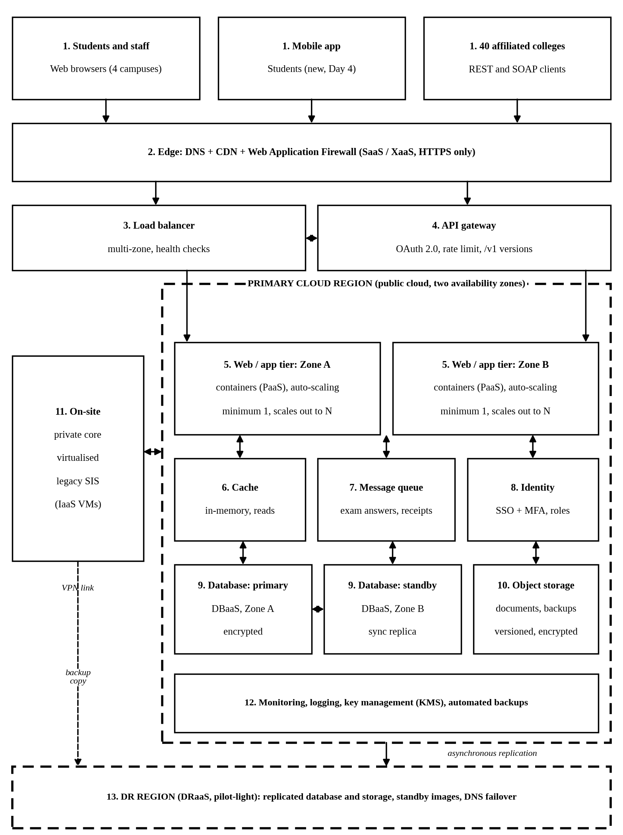
Figure 1: Proposed hybrid cloud architecture. Numbers correspond to the component table in Section 8.3. Solid arrows show request flow, double arrows show two-way traffic, and dashed boxes and arrows show region boundaries and backup or replication flows.
8.3 Components, Deployment Model, Service Model and Justification
Component | Deployment and service model | Justification
1. Users and clients | Public internet; SaaS-style access through browser, app and API | Broad network access: one entry point for four campuses, the mobile app and 40 colleges, with nothing to install.
2. Edge: DNS, CDN, WAF | Public cloud; XaaS | The CDN serves cacheable reads (results, catalogue) so they never reach the app tier; the firewall blocks common attacks; DNS performs failover.
3. Load balancer | Public cloud; managed service | Spreads traffic across both zones and removes unhealthy instances using health checks.
4. API gateway | Public cloud; PaaS | Single front door for the Task 5 web services: OAuth 2.0, rate limiting and versioning protect the back end during surges.
5. Web / app tier | Public cloud; PaaS containers | Stateless containers scale out horizontally, one group per zone; the platform patches the operating system.
6. Cache | Public cloud; managed PaaS | Serves repeated reads from memory, sharply reducing database load on result day.
7. Message queue | Public cloud; managed PaaS | Decouples exam submission from processing so no answer is lost in a surge, and gives a trigger for scaling.
8. Identity | Identity as a Service; XaaS | One login with multi-factor authentication for every application and every college; central removal of access.
9. Database tier | Public cloud; DBaaS | Primary and standby in separate zones with automatic failover, backups, patching and read replicas.
10. Object storage | Public cloud; IaaS-level service | Cheap, durable storage for documents, receipts and backups, with versioning and encryption.
11. On-site private core | Private cloud; IaaS (3 hosts plus 1 spare from Task 4) | Keeps the legacy SIS running during gradual migration, retains control of sensitive records and reuses existing investment.
12. Monitoring, logging, KMS | Managed services; SaaS and XaaS | Provides visibility, audit trails and encryption-key control, and supplies the metrics that drive auto-scaling.
13. DR region | Second public-cloud region; DRaaS | Fills the missing recovery site at pilot-light cost, using the recovery targets from Task 7.

Overall models: the deployment model is hybrid: a private on-site core, a public-cloud region for elasticity and recovery, and a community-style shared service for the 40 affiliated colleges through the API layer. The service-model mix follows Task 6: SaaS for email and identity, PaaS for the LMS, Exam Portal and the API tier, IaaS for the legacy SIS, and XaaS for DBaaS and DRaaS.
8.4 Elasticity: Handling Admissions and Exam Peaks
Elasticity works on three levels. First, the CDN and cache remove most read traffic before it reaches the servers. Second, the app tier scales out automatically, using a rule of thumb of fast scale-out and slow scale-in: add instances when average CPU stays above 60% for three minutes, and remove them only after CPU stays below 30% for ten minutes. Third, known events are scheduled: because admissions, results and exams are announced in advance, capacity is pre-warmed shortly before they start instead of waiting for load to arrive.
Event | Trigger | Scaling action | App instances (illustrative)
Normal term time | Baseline | Minimum of one instance group per zone. | 2
Admissions | Scheduled pre-warm plus CPU above 60% | Warm cache and CDN; scale out the app tier. | 10 rising to 40
Result publication | Scheduled plus requests per instance | Cache result pages at the CDN; scale the app tier. | 10 rising to 30
Online exams | Queue depth plus CPU; pre-scaled before start | Scale workers on queue length; add database read replicas. | 6 rising to 40
After the event | CPU below 30% for ten minutes | Gradual scale-in to the baseline. | Back to 2

A maximum of 40 instances and a budget alert act as cost guardrails, so a faulty rule or an attack cannot create an unlimited bill. Exam answers pass through the queue, so even if processing briefly lags, nothing is lost.
The elasticity dividend. Compare a fixed fleet sized for the peak with the elastic plan, using an illustrative assumption that peak load lasts 30 days (720 hours) in a year. A fixed fleet of 40 instances runs 40 x 8,760 = 350,400 instance-hours. The elastic plan runs a baseline of 2 x 8,760 = 17,520 hours, plus 38 extra instances for 720 hours, which is 27,360 hours, for a total of 44,880 instance-hours. The saving is 305,520 hours, or about 87%. This is a conservative estimate because the plan does not run 40 instances for every peak hour.
8.5 Security Measures
Area | Measures
Access control | Single sign-on with multi-factor authentication; role-based access with least privilege; administrator access granted just in time and logged; OAuth 2.0 scopes on the APIs; the database sits in a private network segment reachable only from the app tier.
Encryption | TLS 1.2 or higher for all traffic in transit; AES-256 encryption at rest for the database, object storage and backups; keys held in a key management service with rotation.
Backup | Automated daily snapshots plus continuous log backup for point-in-time recovery; copies stored in the DR region; object versioning and defined retention; restore tested every quarter.
Network protection | Web application firewall and distributed denial-of-service protection at the edge; network segmentation between web, application and data tiers.
Monitoring and compliance | Central logs and alerts with an audit trail; student data kept in an in-country region; breach-response process aligned with the Digital Personal Data Protection Act 2023.

8.6 Availability Measures and Calculation
Every tier runs in two zones, health checks remove failed instances, the database fails over automatically, and a second region holds a recovery copy. The target is 99.9%, which allows 525,600 x 0.001 = 525.6 minutes (8.76 hours) of downtime a year. Because the tiers are in series, their availabilities multiply. The values below are illustrative assumptions, with failures assumed independent.
Tier | Assumed availability | Basis
Edge and load balancer | 99.99% | Managed, redundant service.
API gateway | 99.95% | Managed service.
App tier (two zones) | 99.9975% | Each zone 99.5%: 1 - (0.005 x 0.005).
Database (primary and standby) | 99.9975% | Each copy 99.5%: 1 - (0.005 x 0.005).

Combined availability = 0.9999 x 0.9995 x 0.999975 x 0.999975 = about 99.935%. The expected downtime is (1 - 0.99935) x 525,600 = about 342 minutes, or 5.7 hours a year, inside the 8.76-hour allowance. The margin is deliberately thin to show why every extra component placed in series must be justified, which is the same dependency lesson as in Task 7. If a zone or the whole region fails, DRaaS restores service within the recovery targets proposed in Task 7.
8.7 Traceability to the Day-4 Requirements
Requirement | How the architecture meets it
Ten times the current peak | CDN, cache, queue and auto-scaling app tier absorb the load with rented capacity.
99.9% availability | Two zones per tier, automatic database failover and a DR region; calculated at 99.935%.
Limited budget | Small baseline, pay-per-use peaks (about 87% fewer instance-hours than a fixed peak fleet), SaaS for email and identity, and pilot-light DR.
Mobile app and 40 colleges | API gateway with OAuth 2.0 and versioned REST and SOAP services from Task 5.
No disaster recovery site | DRaaS in a second region with tiered recovery targets.
Monolithic applications | Legacy SIS stays on the private core and is replaced gradually using the Strangler Fig approach.

TASK 9: HANDS-ON IMPLEMENTATION AND DOCUMENTATION
9.1 What was built and why this function
The function chosen for the proof of concept (PoC) is student fee status and payment, a slice of the Student Information System. It was chosen because it is the exact function that Day 4 will expose to the mobile app and to 40 affiliated colleges, so the PoC doubles as an early test of the API-first and multi-tenant ideas in the final design.
The PoC has three parts. Each one maps to a service model that the full design uses, which is what makes it a faithful miniature and not an unrelated demo.
PoC component | Service model | What it demonstrates | Where it sits in the full design
Docker container (Nginx or gunicorn with Flask) on a Linux virtual machine | IaaS | Virtualisation: one VM hosts an isolated, portable application unit that starts in seconds | Containers hosting the SIS and Exam Portal services
REST API with /health, /fees and /payments endpoints | Web service | A machine-readable interface usable by a browser, curl or a mobile app | The public API for the mobile app and the 40 colleges
Serverless late-fee function (AWS Lambda; Azure Functions or Google Cloud Functions work equally well) | PaaS (FaaS) | No server to patch; billed only per invocation; scales by itself | Burst-prone calculations during admissions and result weeks
Static page on object storage or GitHub Pages (optional) | SaaS / PaaS | Zero-server hosting of the front end | Student portal landing pages served through a CDN

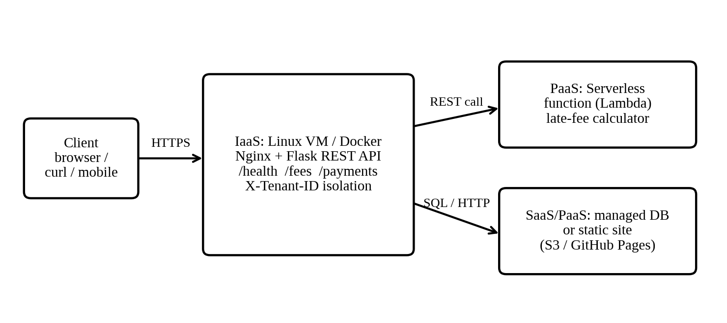
Figure 9.1: Architecture of the proof of concept.
9.2 Environment
Item | Value
Compute (option A) | AWS EC2 t3.micro (free tier), Ubuntu Server 24.04 LTS, 1 vCPU, 1 GB RAM, 8 GB gp3 volume
Compute (option B) | VirtualBox VM with Ubuntu 24.04, 1 vCPU, 1 GB RAM, bridged or NAT port forward 8080 to 5000
Runtime | Docker Engine, Python 3.12, Flask 3.1, gunicorn
Serverless | AWS Lambda, Python 3.12 runtime, Function URL enabled
Test clients | curl 8.x, web browser, Postman (optional)
Security group or firewall | Inbound 22 from my own IP only; inbound 80 from anywhere for the demo
The application code was executed and tested in a Linux sandbox using the same source files that are listed in Appendices A and B. The outputs in this report are therefore real program output, not mock-ups.
9.3 Reproducible configuration steps
Part A: virtual machine and container (IaaS)
- Create the VM. In the EC2 console choose Launch Instance, select Ubuntu 24.04 and t3.micro, create a key pair, and set the security group as in 9.2. On VirtualBox, create a new 1 GB Ubuntu VM instead.
- Connect. Run: ssh -i key.pem ubuntu@<public-ip>
- Install Docker. Run: sudo apt update && sudo apt install -y docker.io, then: sudo usermod -aG docker $USER and log in again.
- Create the project folder with app.py, static/index.html, requirements.txt and Dockerfile (see Appendix A).
- Build the image: docker build -t nimbus-fees:1.0 .
- Run the container: docker run -d --name fees -p 80:5000 --restart unless-stopped nimbus-fees:1.0
- Verify it is running: docker ps (the status should read Up) and docker logs fees.
Part B: serverless function (PaaS)
- Open AWS Lambda, choose Create function, then Author from scratch, name it lateFeeCalculator, runtime Python 3.12.
- Paste the code from Appendix B into lambda_function.py and choose Deploy.
- Under Configuration, choose Function URL, create it with auth type NONE (acceptable for a PoC only; production uses API Gateway with JWT authorisation).
- Open the URL in a browser with the query string ?balance=12500&due_date=2026-11-15&today=2026-11-25.
Part C: static front end (SaaS / PaaS, optional)
- Create an S3 bucket (or a GitHub repository), upload static/index.html, and enable static website hosting (or GitHub Pages).
- Open the site URL and use the form; it calls the REST API from Part A.
Part D: clean-up
Stop or terminate the EC2 instance, delete the Lambda function and empty the bucket, so that the free-tier allowance is not exceeded.
9.4 Testing the web service with a client
The service was tested with curl. Figure 9.2 shows the first four tests. The numbered markers in the figure correspond to the explanation below it.
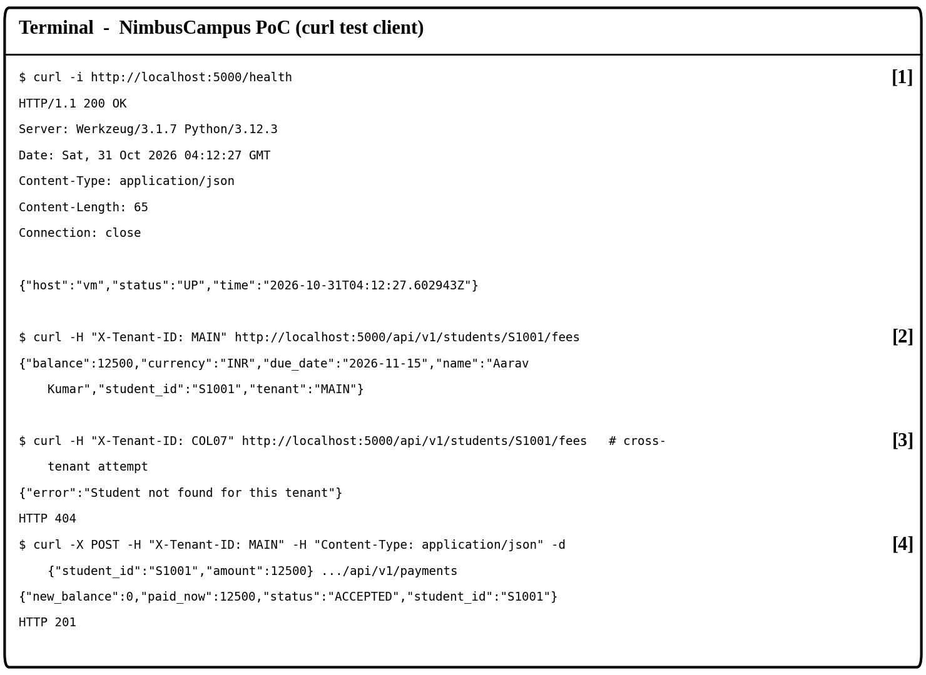
Figure 9.2: Annotated curl session against the containerised API.
Marker | What to look at | Meaning
[1] | HTTP/1.1 200 OK and status UP | The health endpoint proves the service is alive. A load balancer uses exactly this kind of check to decide whether to send traffic to an instance.
[2] | Balance 12500 for tenant MAIN | The data comes back as JSON, so a browser, a mobile app or another college's software can read it.
[3] | HTTP 404 when tenant COL07 asks for S1001 | Tenant isolation works. College 07 cannot see the main campus student, which is the core Day-4 security requirement.
[4] | HTTP 201 and new balance 0 | A payment is accepted, the state changes, and the correct HTTP status for resource creation is returned.

Three further tests covered error handling. They are listed in the results table below.
No. | Request | Expected | Actual | Result
T1 | GET /health | 200 and status UP | 200, status UP, 0.9 ms average over 200 calls | Pass
T2 | GET /fees as MAIN for S1001 | 200 and balance 12500 | 200, balance 12500 | Pass
T3 | GET /fees as COL07 for S1001 (cross-tenant) | 404, no data leaked | 404, error message only | Pass
T4 | POST /payments of 12500 as MAIN | 201 and balance 0 | 201, new_balance 0 | Pass
T5 | GET /fees with no X-Tenant-ID header | 401 | 401, Unknown or missing X-Tenant-ID | Pass
T6 | POST /payments with amount -5 | 400 | 400, amount must be a positive number | Pass
T7 | Lambda: balance 12500, 10 days late | Late fee 500, total 13000 | late_days 10, late_fee 500, total_payable 13000 | Pass

Browser test. Opening http://<public-ip>/ shows the fee page. Entering tenant MAIN and student S1001 and pressing Check balance displays the same JSON as marker [2].
9.5 Issues faced and how they were resolved
Issue | Cause | Resolution
permission denied while running docker commands | The user was not in the docker group | Ran sudo usermod -aG docker $USER and opened a fresh SSH session
Browser could not reach the VM on port 80 | The security group allowed only SSH | Added an inbound rule for TCP 80; confirmed with curl from the laptop
Port already in use when starting the container | An earlier container was still bound to port 80 | docker rm -f fees, then ran the command again
Front-end page showed a cross-origin (CORS) error when served from a different host | The browser blocks calls to another origin by default | Served the page from the same container; for production, enable CORS on the API gateway for the approved origins only
Lambda returned an internal error on the first test | The handler name did not match the file name | Set the handler to lambda_function.lambda_handler
9.6 What the proof of concept proves
- Virtualisation delivers speed. A new service went from nothing to running in minutes, against 6 to 8 weeks to procure a physical server.
- Web services make the application reusable. The same API answers a browser, curl and, later, a mobile app without any change.
- Serverless removes idle cost. The late-fee function costs nothing when nobody calls it, which suits a function used heavily only around due dates.
- Isolation can be demonstrated, not just claimed. Test T3 shows one college cannot read another's student.
- Limits are honest. The PoC keeps data in memory and trusts a header for the tenant. Production would use a managed database and derive the tenant from a signed token .

TASK 10: EVALUATE AND RECOMMEND THE FINAL SOLUTION
10.1 Comparison of the three options
Criterion | On-premise (refresh) | IaaS (lift and shift) | PaaS / SaaS hybrid
Cost model | High CapEx up front, then fixed OpEx whether used or not | No CapEx; OpEx for VMs that are often over-sized | No CapEx; OpEx tracks real use; SaaS replaces whole systems
Scalability | Fixed. New capacity takes 6 to 8 weeks to buy | Minutes to add a VM, but scaling is still managed by staff | Automatic scaling out and back in during admissions and exams
Availability | Single data centre, no DR site; around 99% is realistic | Multi-zone possible; 99.9% achievable with design effort | Provider-managed multi-zone services plus a second region; 99.9% or better
Security | Full control, but the university patches and monitors everything | Shared responsibility: provider secures the host, university secures the guest OS | Provider secures more of the stack; university focuses on identity, data and configuration
Effort (manageability) | Highest: hardware, OS, middleware, backups, DR | Medium: OS and middleware remain our work | Lowest: patching and scaling are the provider's job
Time to launch a new service | Weeks | Hours | Minutes

Weighted decision matrix
Each option is scored from 1 (poor) to 5 (excellent). The weights reflect the scenario: scalability and cost are the main pain points, availability is a Day-4 target, and security cannot be sacrificed.
Criterion | Weight | On-premise | IaaS | PaaS / SaaS
Cost (CapEx and OpEx) | 25% | 2 | 3 | 5
Scalability | 25% | 1 | 4 | 5
Availability and DR | 20% | 2 | 4 | 5
Security and compliance | 15% | 3 | 3 | 4
Effort and manageability | 15% | 2 | 3 | 4
Weighted score (out of 5) | 100% | 1.90 | 3.45 | 4.70
Working for the on-premise total: 0.25 x 2 + 0.25 x 1 + 0.20 x 2 + 0.15 x 3 + 0.15 x 2 = 1.90. The PaaS/SaaS option scores lower on security than on other criteria because responsibility is shared and misconfiguration becomes the main risk; this is why the risk plan in 10.3 puts identity and configuration first.

10.2 Three-year cost comparison

Stated assumptions (all figures in Rs lakh; 1 lakh = 100,000)
Item | On-premise | IaaS | PaaS / SaaS hybrid
One-time cost (CapEx or migration) | 110: 12 servers at 4.5 each (54), storage and network (18), power and cooling upgrade (8), basic DR site (30) | 12: migration effort and training | 20: refactoring for APIs, data migration, training
Yearly running cost (year 1) | 51: power and cooling 8, maintenance contracts 9, 3 system administrators 24, licences and backup 10 | 66: reserved VMs 28, storage and backup 6, network egress 4, DR replica 8, 2 administrators 16, licences 4 | 40: managed containers and autoscaling 12, managed database 8, storage, backup and CDN 4, API gateway, serverless and monitoring 4, DR 4, platform engineering 8
Yearly growth | 5% | 5% | 5%
E-mail | Included in the server estimate | Included in the VM estimate | Education-edition SaaS e-mail assumed at no licence cost
These are planning estimates, not quotations. Before approval they must be rebuilt in the chosen provider's pricing calculator with real instance sizes, and the education discounts must be confirmed.

Year | On-premise | IaaS | PaaS / SaaS hybrid
Year 1 (one-time plus running) | 161.0 | 78.0 | 60.0
Year 2 | 53.6 | 69.3 | 42.0
Year 3 | 56.2 | 72.8 | 44.1
3-year total | 270.8 | 220.1 | 146.1
Saving of hybrid | 124.7 (46%) | 74.0 (34%) | not applicable

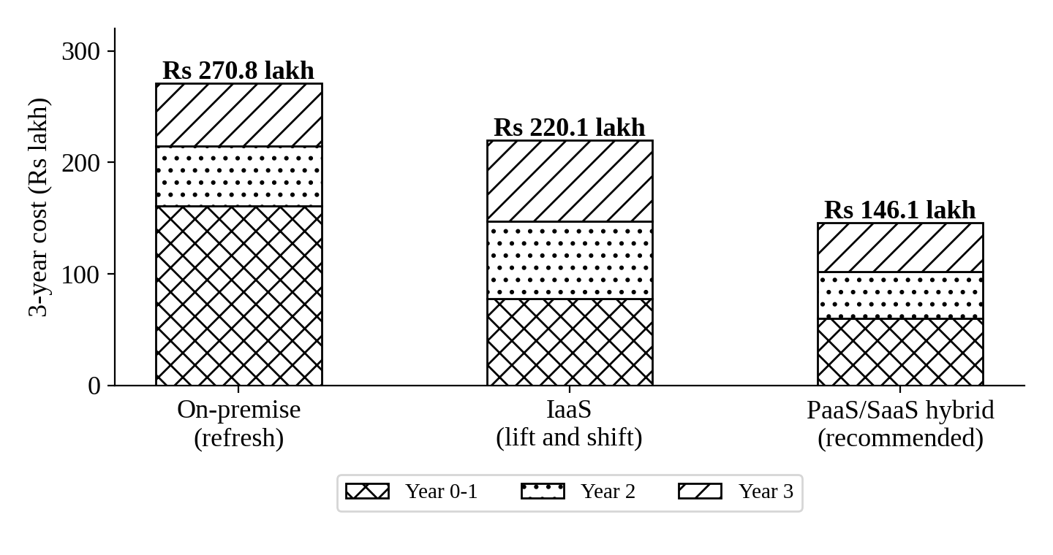
Figure 10.1: Three-year cost by option, in Rs lakh.
Reading the result. The hybrid is cheapest from the first year, because it avoids the Rs 110 lakh hardware purchase and the standing staff cost. It also takes the Day-4 surge in its stride: the on-premise figure above does not include extra hardware for ten times the load, which would add a large further CapEx, whereas the hybrid's autoscaling raises cost only while the load is actually present.
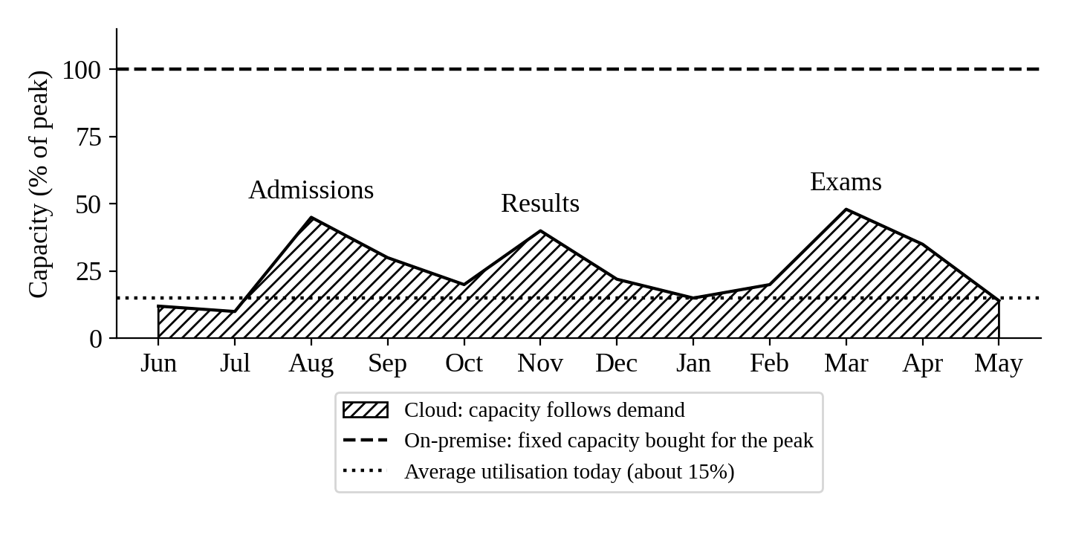
Figure 10.2: Capacity needed through the academic year compared with fixed on-premise capacity.

10.3 Risk analysis and mitigation
Risk | Likelihood | Impact | Mitigation steps
Vendor lock-in | Medium | High | Use containers, PostgreSQL and open-source Moodle so workloads can move; keep infrastructure definitions in Terraform; wrap provider-specific services behind our own API layer; hold a documented exit plan and test a restore on a second provider once a year.
Data privacy and legal compliance | Medium | High | Keep student records in India-hosted regions to respect data-protection law; encrypt at rest and in transit with university-held keys; sign a data-processing agreement; apply role-based access and audit logs; classify data before migration.
Downtime or provider outage | Low | High | Deploy across at least two availability zones; replicate to a second Indian region; set recovery targets (RTO 1 hour, RPO 15 minutes); run a DR drill every semester; publish a status page.
Skills gap | High | Medium | Train 6 staff in cloud fundamentals before Phase 1; pair each with a partner engineer; write runbooks; migrate the lowest-risk system first so mistakes are cheap.
Cost overrun | Medium | Medium | Budget alerts at 50%, 80% and 100%; tag every resource by application; shut down test environments at night; use reserved or committed pricing only for steady workloads.
Security misconfiguration | Medium | High | Single sign-on with multi-factor authentication; least-privilege roles; automated configuration scanning; web application firewall in front of every public API.
Migration failure or data loss | Low | High | Run old and new systems in parallel; migrate in weekly cut-overs outside exam windows; verify with checksums; keep the old server for 30 days as rollback.

10.4 Final recommendation
Recommendation: adopt a SaaS-first, PaaS-where-it-scales hybrid, hosted with one primary and one in-country disaster-recovery region.
SaaS for commodity systems (e-mail, and where suitable the library). PaaS (managed containers, managed database, serverless) for the systems that need elasticity: LMS, Exam Portal and the Student Information System APIs. IaaS only as a temporary home for anything that cannot yet be refactored. XaaS is added for identity (IDaaS), API management, monitoring and disaster recovery.

Why this provider choice is justified and not merely popular
All three large providers operate several regions in India, so popularity is not the deciding factor. The recommendation rests on the criteria below, and the same table must be re-scored if quotations change them.
Criterion | Why it matters here | How the recommendation meets it
Two regions inside India | Student data must stay in the country and DR needs a second site | Choose a provider pair such as Mumbai and Hyderabad (AWS), so both primary and DR stay in India
Serverless and container maturity | Burst-driven load suits functions and autoscaling containers | The PoC in Task 9 ran on exactly these services, proving fit and reducing skills risk
Free tier and education pricing | The operating budget is limited | A free tier let the PoC be built at no cost; education credits and e-mail SaaS reduce year-1 spend
Portability | Lock-in is a named risk | Docker, PostgreSQL and open-source Moodle run on any provider
Existing skills and support | Skills gap is the highest-likelihood risk | Largest training catalogue and local partner availability
Azure or Google Cloud would be acceptable substitutes if their quotation is lower for the same sizing; because the design uses open standards, switching before Phase 1 costs little.

10.5 Migration roadmap: what moves first and why
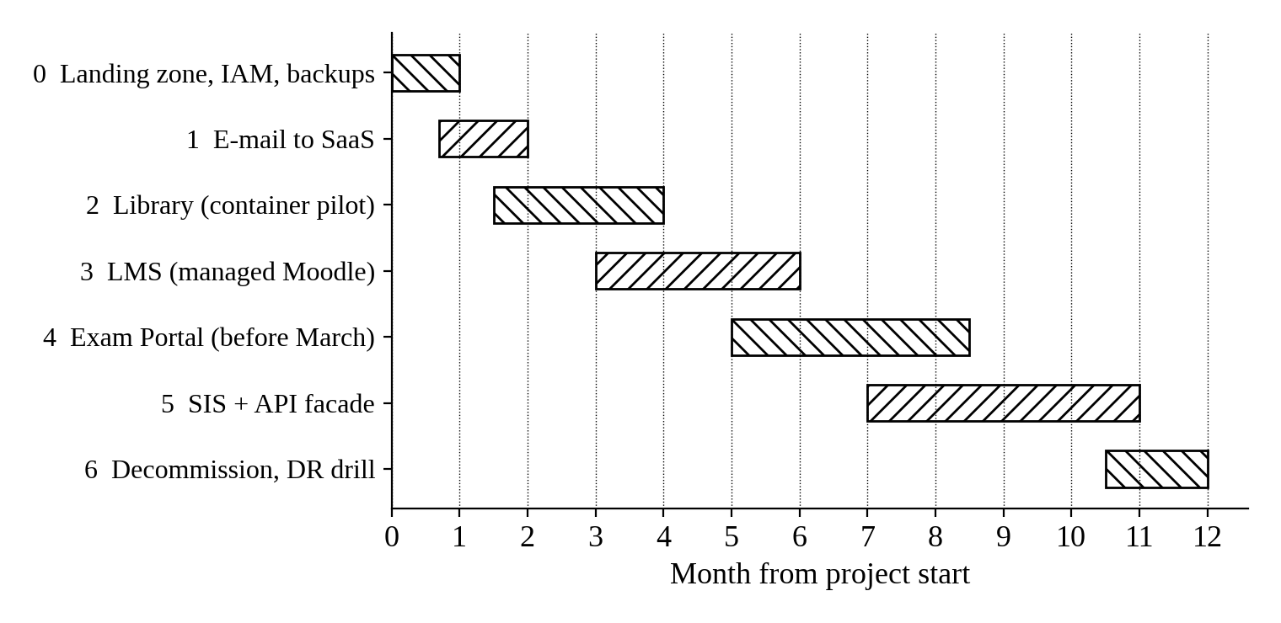
Figure 10.3: Twelve-month migration roadmap.
No. | Application | Target model | Why in this position
0 | Foundation: accounts, identity, network, backup, monitoring | IaaS and XaaS | Everything else depends on it; costs little; builds the skills.
1 | E-mail (first to move) | SaaS | Lowest risk, no custom code, no dependencies, immediate saving, and it frees a server. It trains staff and builds confidence with a visible win.
2 | Library system | Container pilot on PaaS | Low criticality and a small user base; a safe place to learn containers and managed databases.
3 | Learning Management System | Managed Moodle on PaaS | Heavy but predictable load; autoscaling pays off. Complete before the next semester begins.
4 | Exam Portal | PaaS with autoscaling and a queue | The biggest beneficiary of elasticity. Must be load-tested and live before the March exam window.
5 | Student Information System with API facade | PaaS and API gateway | Most critical and most tangled, so it moves last using the strangler pattern: new API endpoints are added in front, and old features are replaced one at a time. This also delivers the Day-4 mobile and college APIs.
6 | Decommission servers; DR drill | Not applicable | Savings start only when old hardware is switched off.

TASK 11: RE-EVALUATE AND ADAPT THE DESIGN (IMPACT ANALYSIS)

11.1 What has changed from the original problem
Dimension | Original problem | Day-4 announcement
Who uses the system | About 25,000 students and 2,000 staff on 4 campuses | The same people plus mobile users and the students and staff of 40 affiliated colleges
How they reach it | Browser, from inside or near the campus | Mobile app and partner software over the internet, at any hour
Peak load | Above 95% CPU on a single server in admissions and exam weeks | Ten times the current peak
Availability | Failures during peak; no DR site; no stated target | Contractual 99.9%
Services exposed | Internal use only | Student records and fee payment, which are the most sensitive services
Money | Capital budget for new servers was an option | Limited operating budget
Nature of the system | A set of internal applications | A platform that other institutions depend on

11.2 Which original assumptions are affected
To make the effect measurable, the sizing below states its own assumptions. Peak concurrent sessions in the original design are taken as about 6,000 (22% of 27,000 users) and each session as 3 requests per minute. The 40 colleges are assumed to average 1,500 students each.
Assumption | Original | Now | Effect on the design
Peak concurrent sessions | About 6,000 | About 60,000 | Fixed-size capacity is no longer realistic; autoscaling, caching and a CDN become compulsory
Peak request rate | About 300 per second | About 3,000 per second | The database becomes the bottleneck first; add read replicas, caching and queueing of writes
Registered users | About 27,000 | About 87,000 (27,000 + 40 x 1,500) | Identity must be a managed service that supports many organisations
Availability | Best effort, around 99% (about 87.6 hours down a year) | 99.9% (8.76 hours a year, 43.8 minutes a month) | Single points of failure must go; two zones plus tested failover
Cost behaviour | Cost grows in steps when hardware is bought | Cost must grow smoothly with use and stay inside a limited budget | Pay-per-use, scheduled scale-down, serverless for spiky APIs, and a hard budget alert
Trust boundary | Inside the campus network | Open to the internet and to other organisations | Zero-trust thinking: every call is authenticated, authorised, logged and rate-limited

Why 99.9% is harder than it sounds
Availability multiplies along a chain. If a request needs a gateway, an application tier and a database, each at 99.9%, the whole chain delivers 0.999 x 0.999 x 0.999, about 99.7%, which is roughly 26 hours of downtime a year and misses the target. Running each tier in two availability zones removes the single points of failure, so the chain can meet 99.9% provided that failover is automatic and rehearsed.

11.3 Why web services and APIs now become critical
In the original scenario an API was a convenience. After Day 4 it is the product, for four reasons.
- The mobile app cannot use a monolith's screens. It needs data, not web pages. Only a documented interface returning JSON can serve it.
- Forty colleges must connect their own software. Machine-to-machine access needs a stable contract (an OpenAPI specification), version numbers and backward compatibility so that one college's upgrade does not break another.
- APIs let the system scale in parts. Once fees, records and payments are separate services, the fee service can scale up in payment week without scaling the rest.
- An API gateway becomes the control point. It authenticates each call, enforces per-college rate limits, caches popular answers, records usage for billing and audit, and shields the back end from attack.
Gateway duty | Day-4 risk it removes
Authentication with OAuth 2.0 and signed tokens | Anyone calling the fee or records service without permission
Rate limiting per college (usage plans) | One college's bug or traffic spike starving the others
Response caching and CDN | Needless load on the database for repeated reads
Request validation and web application firewall | Malformed and malicious requests reaching the application
Versioning (for example /api/v1) | Breaking 40 integrations whenever the system is improved
Logging and metrics per tenant | Not knowing who did what, or which college is slow
The Task 9 PoC already follows this pattern: a versioned path, JSON responses, correct status codes, and a tenant check on every call.

11.4 How multi-tenant access by 40 colleges affects security and isolation
Opening student records to 40 institutions means one platform serves many tenants who must never see each other's data. The central threat is cross-tenant data exposure, usually through a missing check on an identifier. The design choice is how strongly to separate tenants, and each choice trades isolation against cost.
Isolation model | How it works | Strength | Cost
Silo | A separate database and compute stack per college | Strongest isolation; easy to prove to an auditor | Highest. Forty copies exceed a limited budget
Pool | All colleges share one database and one stack, separated by a tenant column | Cheapest and simplest to scale | Lowest, but one coding error can leak data
Bridge (recommended) | Shared compute, with one schema or enforced row-level security per tenant, and a separate encryption key per college for the most sensitive tables | Strong isolation at moderate cost | Moderate; fits a limited budget

Threats and controls
Threat | Control
A college reads another college's student by guessing an ID | Tenant identity is taken from a signed token claim, never from a value the caller supplies; every query is filtered by tenant; row-level security in the database acts as a second lock. Test T3 in Task 9 demonstrates the principle.
Stolen or shared credentials | Separate client credentials per college; short-lived tokens; multi-factor authentication for staff consoles; immediate revocation.
Noisy neighbour: one college overloads the platform | Per-tenant rate limits and quotas; autoscaling with a spend cap; queue write-heavy operations.
Payment data exposure | Card details never touch the university's systems. A hosted payment gateway tokenises them, which keeps the university out of the heaviest payment-card compliance scope.
Privilege escalation inside a college | Roles such as student, college admin and university admin, each with least privilege; college admins can only see their own tenant.
Disputes and breaches cannot be investigated | Immutable audit logs stamped with tenant and user; central monitoring and alerts.
Legal responsibility for personal data is unclear | A written data-sharing agreement with each college states who may see what, how long it is kept, and who reports a breach.
Honest note on the PoC. In Task 9 the tenant is read from a request header to keep the demonstration simple. A header can be forged, so production must replace it with a claim inside a verified token, as the table above requires.

11.5 Summary of the impact and the direction it points to
Impact in one paragraph. The load is ten times larger, the audience is no longer inside the campus, the services are the most sensitive ones the university owns, the availability target is now a promise, and the budget forbids buying hardware to meet it. Each of these pushes the same way: toward elastic managed services, an API gateway as the single front door, and tenant isolation designed in from the start.
Direction. The original hybrid design is sound in principle, so a complete redesign is not required. It needs modification in three places: the API gateway and identity move from Phase 5 to the start, the database layer gains replicas and caching, and multi-tenant isolation (bridge model) is added to the SIS.

APPENDIX A: POC SOURCE CODE (CONTAINER)

app.py
"""NimbusCampus PoC - Student Fee Status REST API (one university function)."""
from flask import Flask, jsonify, request, send_from_directory
import datetime, os, socket

app = Flask(__name__, static_folder="static")

# In-memory sample data, keyed by tenant (college) -> student. Stands in for a managed DB.
DATA = {
"MAIN": {"S1001": {"name": "Aarav Kumar", "due": 42500, "paid": 30000, "due_date": "2026-11-15"}},
"COL07": {"S2001": {"name": "Meena Devi", "due": 38000, "paid": 38000, "due_date": "2026-11-15"}},
}

def tenant():
return request.headers.get("X-Tenant-ID", "").upper()

@app.get("/")
def home():
return send_from_directory("static", "index.html")

@app.get("/health")
def health():
return jsonify(status="UP", host=socket.gethostname(),
time=datetime.datetime.utcnow().isoformat() + "Z")

@app.get("/api/v1/students/<sid>/fees")
def fees(sid):
t = tenant()
if t not in DATA:
return jsonify(error="Unknown or missing X-Tenant-ID"), 401
rec = DATA[t].get(sid)
if rec is None: # tenant isolation: other colleges' IDs are invisible
return jsonify(error="Student not found for this tenant"), 404
return jsonify(tenant=t, student_id=sid, name=rec["name"],
balance=rec["due"] - rec["paid"], currency="INR",
due_date=rec["due_date"])

@app.post("/api/v1/payments")
def pay():
t = tenant()
body = request.get_json(silent=True) or {}
sid, amt = body.get("student_id"), body.get("amount")
if t not in DATA or sid not in DATA[t]:
return jsonify(error="Student not found for this tenant"), 404
if not isinstance(amt, (int, float)) or amt <= 0:
return jsonify(error="amount must be a positive number"), 400
DATA[t][sid]["paid"] += amt
return jsonify(status="ACCEPTED", student_id=sid, paid_now=amt,
new_balance=DATA[t][sid]["due"] - DATA[t][sid]["paid"]), 201

if __name__ == "__main__":
app.run(host="0.0.0.0", port=int(os.environ.get("PORT", 5000)))

Dockerfile
FROM python:3.12-slim
WORKDIR /app
COPY requirements.txt .
RUN pip install --no-cache-dir -r requirements.txt
COPY app.py .
COPY static ./static
ENV PORT=5000
EXPOSE 5000
CMD ["gunicorn", "-b", "0.0.0.0:5000", "-w", "2", "app:app"]

requirements.txt
flask==3.1.3
gunicorn==22.0.0

APPENDIX B: SERVERLESS FUNCTION (LAMBDA_FUNCTION.PY)
import json, datetime

def lambda_handler(event, context):
"""Serverless late-fee calculator: Rs 50 per day after due date, capped at Rs 1,000."""
q = (event.get("queryStringParameters") or {})
balance = float(q.get("balance", 0))
due = datetime.date.fromisoformat(q.get("due_date", "2026-11-15"))
today = datetime.date.fromisoformat(q.get("today", datetime.date.today().isoformat()))
late_days = max((today - due).days, 0)
fine = min(late_days * 50, 1000) if balance > 0 else 0
return {"statusCode": 200, "headers": {"Content-Type": "application/json"},
"body": json.dumps({"late_days": late_days, "late_fee": fine,
"total_payable": balance + fine, "currency": "INR"})}

Local test of this function with balance 12500, due date 2026-11-15 and today 2026-11-25 returned: late_days 10, late_fee 500, total_payable 13000.0, currency INR.

